Subject: LinkedIn Top Skills 2016  
The 2016 Global Skills List reveals many trends on scientific progress, labor market demand and country ranking by skill. I chose three skills required in the global and Arab labor market, particularly by analyzing the vast amount of data and designing interactive user interfaces. Technical and digital skills are in high demand across the globe, according to research by LinkedIn.

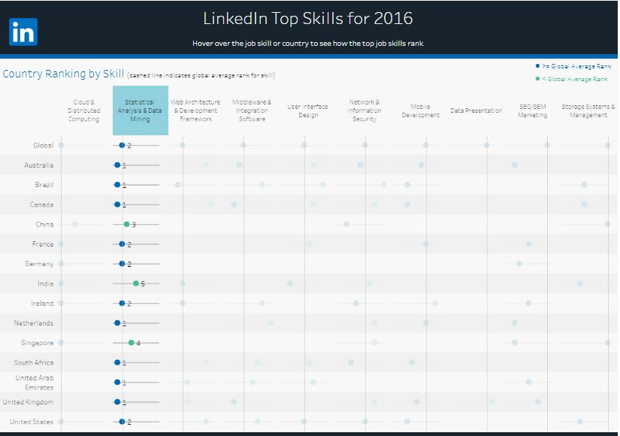**Skill#1 Statistical Analysis and Data Mining:-** Seven countries, including the UK, Canada and Australia, put statistical analysis and data mining in poll position for 2016 while six, including the US and Germany, placed the most value on individuals with cloud computing experience.

>= Global average Rank < Global Average Rank

The picture above shows that all countries have achieved a global ranking. Found that 12 countries appearing in the picture in the circle in blue obtained the highest or equal global average in the skill of statistical analysis and data mining and 3 countries have a lower global ranking illustrated by the green circle in LinkedIn Top Skills 2016. This skill is required more in the global market. As more companies begin to [make use of big data](https://www.icas.com/ca-today-news/10-companies-using-big-data), people who can extract, analyses and translate the useful information are in understandably high demand

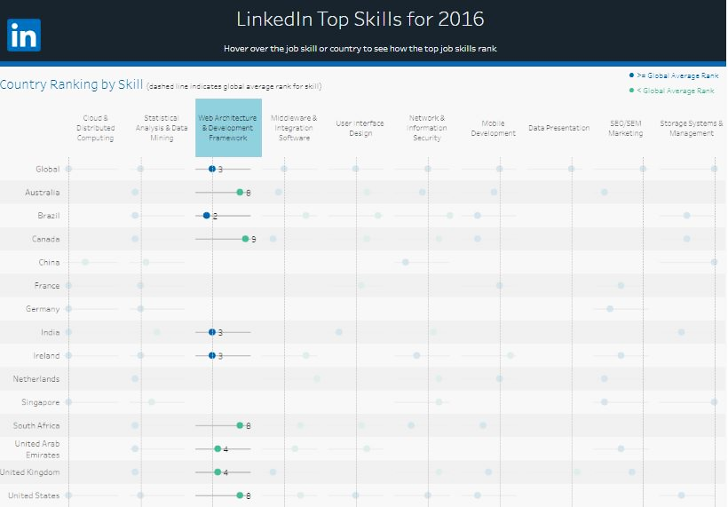**Skill#2** **Web Architecture and Development Framework: -** A company website is arguably the most important public-facing aspect of any business as it is generally the first point of contact potential clients and customers will have

 >= Global average Rank < Global Average Rank

Note in the picture above 4 countries have a world ranking higher or equal to the world ranking circle in blue and 6 countries were ranked in the lowest ranking in the world Web Development Framework skill and the rest of the countries do not have a global order as shown in the picture in LinkedIn Top Skills 2016. Country Ranking by Skill (dashed line indicates global average rank for skill). While these skills are likely to remain the domain of web specialists, understanding the importance of this element to the overall business is a sign of real engagement with the digital age.

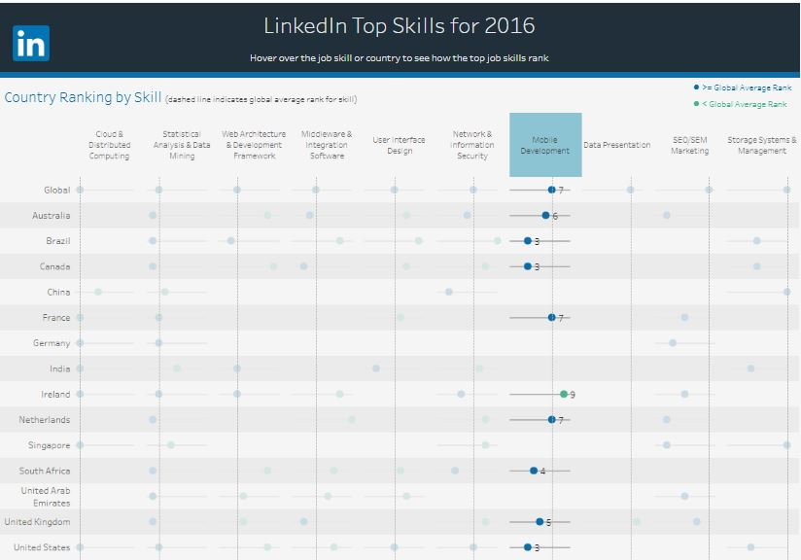 **Skill#3 Mobile Development:-** Apps are where it's at across many industries and sectors. Banks alone, through necessity, are making huge in-roads into mobile and it is clearly a key component to digital innovation. The smart phone development market is one of the most developed markets. Every company is trying to introduce different developments on the phone in order to win the big space for it. This has made this trade profitable and active.

>= Global average Rank < Global Average Rank

In the mobile development skill, six countries ranked top in the world ranking, including Australia, South Africa, Brazil, United Kingdom and United States as shown in the picture. The top three countries maintained the ranking France, Netherlands equal to the world average and one country Ireland got a lower ranking. However, showing a willingness to work with and deliver input to a mobile project will help you promote yourself as a forward-thinking and innovative member of the team.

**I wish everyone success**